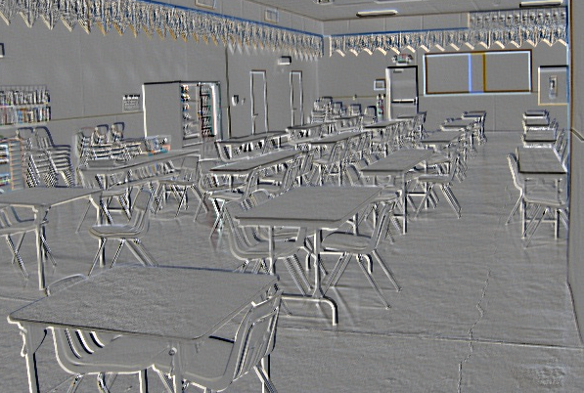

BEDAGGERED
A New Play
By
LYNN CLAY BYRNE

Featuring:
AMARA JAMES AJA*, HENRY AYRES-BROWN*,
DRIA BROWN*, DARRYL CAMPBELL, KARLA GARCIA*,
LAAKAN McHARDY*, GRACE RAO*, MALIK REED*,
LEX SMITH, SEAN STOKES*,
STEVEN ROBERTSON*, MONICA WYCHE*
General Management
DTE MANAGEMENT
Casting by
MICHAEL CASSARA, CSA
Sound Design by
FREDERICK KENNEDY
Directed by
BENJAMIN VIERTEL
*Denotes member of Actors' Equity Association

BEDAGGERED
A New Play
By
LYNN CLAY BYRNE

Featuring:
AMARA JAMES AJA*, HENRY AYRES-BROWN*,
DRIA BROWN*, DARRYL CAMPBELL, KARLA GARCIA*,
LAAKAN McHARDY*, GRACE RAO*, MALIK REED*,
LEX SMITH, SEAN STOKES*,
STEVEN ROBERTSON*, MONICA WYCHE*
General Management
DTE MANAGEMENT
Casting by
MICHAEL CASSARA, CSA
Sound Design by
FREDERICK KENNEDY
Directed by
BENJAMIN VIERTEL
*Denotes member of Actors' Equity Association

CAST (Alphabetical Order)

Massud AMARA JAMES AJA*
McGee/Zeke HENRY AYRES-BROWN*
Kaley DRIA BROWN*
Mohawk DARRYL CAMPBELL
Visitor #1 KARLA GARCIA*
Tisah LAAKAN MCHARDY*
Sorrell/Eve GRACE RAO*
Attis MALIK REED*
Chad/Officer Tabor STEVEN ROBERTSON*
Officer Maroni LEX SMITH
Prisoner Poet/BJ SEAN STOKES*
Arlene MONICA WYCHE*

LOCATION: County Jail, Upstate New York
TIME: The Present

This play will be performed without an intermission and
will have a run time of approximately 90 minutes.

STAFF

STAGE MANAGER Emely Zepeda*
ASSISTANT STAGE MANAGER Bonnie McHeffey*
GENERAL MANAGEMENT DTE Management Services
Ryan Conway, Robert E. Schneider, Andy Lieberman
CASTING Michael Cassara, CSA
PRESS AGENT Keith Sherman & Associates
Scott Klein
PRODUCTION ASSISTANTS Rose Chersi, Donna Olsen
GENERAL MANAGEMENT INTERN Reanne Barrett

SPECIAL THANKS:

David Rothenberg, Lee and Gary Brown,
Richard and Angela Clay,
Peter and Katie Byrne, Rosemary and Bob Chersi,
Barbara and Alan Mandelbaum,
The Fortune Society, Doug Honorof, Ripley-Grier Studios

*Denotes member of Actors’ Equity Association

CAST (Alphabetical Order)

Massud AMARA JAMES AJA*
McGee/Zeke HENRY AYRES-BROWN*
Kaley DRIA BROWN*
Mohawk DARRYL CAMPBELL
Visitor #1 KARLA GARCIA*
Tisah LAAKAN MCHARDY*
Sorrell/Eve GRACE RAO*
Attis MALIK REED*
Chad/Officer Tabor STEVEN ROBERTSON*
Officer Maroni LEX SMITH
Prisoner Poet/BJ SEAN STOKES*
Arlene MONICA WYCHE*

LOCATION: County Jail, Upstate New York
TIME: The Present

This play will be performed without an intermission and
will have a run time of approximately 90 minutes.

STAFF

STAGE MANAGER Emely Zepeda*
ASSISTANT STAGE MANAGER Bonnie McHeffey*
GENERAL MANAGEMENT DTE Management Services
Ryan Conway, Robert E. Schneider, Andy Lieberman
CASTING Michael Cassara, CSA
PRESS AGENT Keith Sherman & Associates
Scott Klein
PRODUCTION ASSISTANTS Rose Chersi, Donna Olsen
GENERAL MANAGEMENT INTERN Reanne Barrett

SPECIAL THANKS:

David Rothenberg, Lee and Gary Brown,
Richard and Angela Clay,
Peter and Katie Byrne, Rosemary and Bob Chersi,
Barbara and Alan Mandelbaum,
The Fortune Society, Doug Honorof, Ripley-Grier Studios

*Denotes member of Actors’ Equity Association

