The First Broadway Revival
of the Beloved Award-Winning Best Musical Once On This Island
Will Open at Circle in the Square Theatre
On December 3, 2017

Tickets On Sale Now

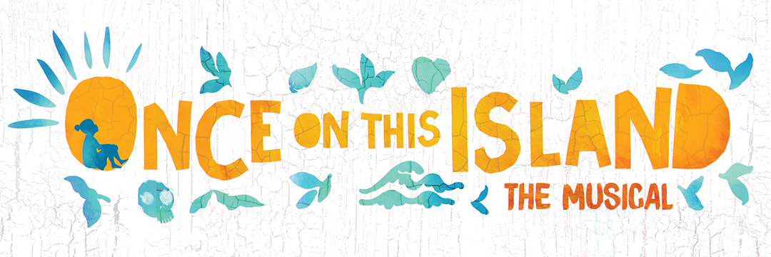
Producers Ken Davenport and Hunter Arnold announced that the first ever Broadway revival of Once on This Island, the Olivier Award-winning and Tony Award-nominated Best Musical, will play the Circle in the Square Theatre (235 W. 50th street, NYC) this fall. Directed by Tony nominee Michael Arden, and choreographed by the critically-acclaimed Camille A. Brown, the production will begin preview performances on Thursday, November 9, 2017 and officially open on Sunday, December 3.

Tickets for Once on This Island are on sale starting today, Thursday, May 11 on Telecharge. Group tickets are available at www.YourBroadwayGenius.com or by calling 855-329-2932.

Once On This Island is written by the Tony Award-winning team of Lynn Ahrens (Book and Lyrics) and Stephen Flaherty (Music), and based on the novel “My Love, My Love” by Rosa Guy. This production will feature new orchestrations by original orchestrator Michael Starobin (Instrumental Orchestrations) and AnnMarie Milazzo (Vocal Orchestrations). The creative team also includes Dane Laffrey (Scenic Design), Tony Award winner Clint Ramos (Costume Design),Jules Fisher and Peggy Eisenhauer (Lighting Designers), and Tony Award winner Nikki M. James (Assistant Director). Additional members of the creative team will be announced soon.

Once On This Island is the Broadway musical celebration that sweeps us across the sea to a small village—where, in the aftermath of a great storm, a joyous new life begins. It is the tale of Ti Moune, a fearless peasant girl who falls in love with a wealthy boy from the other side of the island. When their divided cultures threaten to keep them apart, Ti Moune, guided by the island gods, sets out on a remarkable quest to reunite with the man who has captured her heart.
Bursting with Caribbean colors, rhythms and dance, the story comes to vibrant life through the score by Tony Award® winners Stephen Flaherty and Lynn Ahrens (Anastasia, Ragtime). The striking production by Tony Award-nominated director Michael Arden (Spring Awakening revival) transforms the reality of a tropical village devastated by a storm into a fantastical world alive with hope.

Once On This Island premiered at Playwrights Horizons in May of 1990. The Broadway production opened in October of that year and ran for 469 performances garnering eight Tony nominations including Best Featured Actress (LaChanze), Best Original Score, Best Book of a Musical and Best Musical. The 1994 West End production won the Olivier Award for Best New Musical.

# # #

www.OnceOnThisIsland.com
Follow Once On This Island on Twitter, Facebook, and Instagram: @OnceIslandBway

