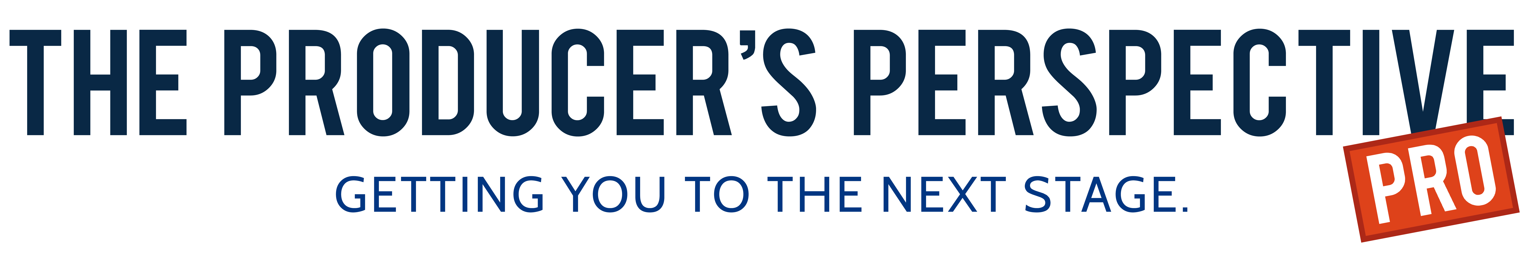

|  |  |
| --- | --- |
| |  | | --- | | Hello Pros!  Well? What did you think? How about those Tonys, huh? Did you watch? ([Click here](https://is-tracking-link-api-prod.appspot.com/api/v1/click/5351764319010816/6306449990877184) to read my Top 5 Favorite Moments from the Awards)  A whole bunch of us watched together at the annual Producer's Perspective PRO Tony party. And a good time, and a whole bunch of wings, was had by all!  If you weren't there, mark your calendar for next year to come out and join us. One of my big tips to folks looking to make a dent in the theater industry who live outside the city is to make a trip in at least 2-4 times a year (it's why the Inner Circle is scheduled 4x a year). Being in the city speeds up your networking connections (which speeds up the development of your show) and it's inspiring walking amongst all the marquees . . . thinking about your show on one! And if you're going to come, what better time of year than Tony time!  Which brings me to this week's Tip . . .  See here's the thing about all those winners last night. At one point in their career, they were just like you. They weren't Tony winners. They just dreamed about being one someday.  And, after a shit-ton of hard work, time, a bunch of rejection, ups, downs and a lot of sideways, and then more time, they found themselves on that stage giving a speech to millions of people.  Let last night's telecast inspire you to do what all those winners did . . . "act." Because that is what's gets people to Radio City. Action.  It happened to them. It can happen to you.  But only if you "act."  Go get 'em. | |
| |  | | --- | | Best, | |

|  |  |
| --- | --- |
| |  | | --- | |  | |
| |  | | --- | | Ken | |

|  |  |
| --- | --- |
| |  | | --- | |  | |
| |  | | --- | | P.S. Our next PRO reading series reading of *Ocean in a Teacup* is scheduled or 3pm on June 24th at Sunlight Studios in NYC. [Click here](https://is-tracking-link-api-prod.appspot.com/api/v1/click/4851077030084608/6306449990877184) to RSVP!  **The Song of the Week is . . .**  **"One Day (Geek Squad Song)"**  From the musical, DEVICES  Music and Lyrics by Inner Circle Members, Mark Brymer and Amy Drake  [Click Here](https://is-tracking-link-api-prod.appspot.com/api/v1/click/6272471626416128/6306449990877184) to listen.  [Click here](https://is-tracking-link-api-prod.appspot.com/api/v1/click/6714629785387008/6306449990877184) for more content.  [This Week on the PRO Facebook Group](https://is-tracking-link-api-prod.appspot.com/api/v1/click/5651192393236480/6306449990877184).  Here are just a few of the things that are being chatted about on the Facebook Group!   * PROny Award Winners Announced! * Tips for fundraising * Tips for branding yourself and your show   [Come join the discussion!](https://is-tracking-link-api-prod.appspot.com/api/v1/click/4540097674870784/6306449990877184)  And here's some more fun and educational stuff we posted for you last week!   * [The 2019 Broadway Tony Award Winners](https://is-tracking-link-api-prod.appspot.com/api/v1/click/5730970471235584/6306449990877184) * [Special Tony Award Post: Three Myths About Tony Award Voting.](https://is-tracking-link-api-prod.appspot.com/api/v1/click/5643302135660544/6306449990877184) * [ANNOUNCED! The 20 shows in our first ever Rave Theater Festival are . . .](https://is-tracking-link-api-prod.appspot.com/api/v1/click/4966326529949696/6306449990877184) * [Broadway Grosses w/e 6/2/2019: Slow and Steady](https://is-tracking-link-api-prod.appspot.com/api/v1/click/4607091816267776/6306449990877184) * [2019 Drama Desk Award Winners](https://is-tracking-link-api-prod.appspot.com/api/v1/click/4760450971992064/6306449990877184) * [Podcast Episode 192 — Six-Time Tony Nominee of The Prom and more, Book Writer/Lyricist Chad Beguelin!](https://is-tracking-link-api-prod.appspot.com/api/v1/click/5902203032698880/6306449990877184) | |