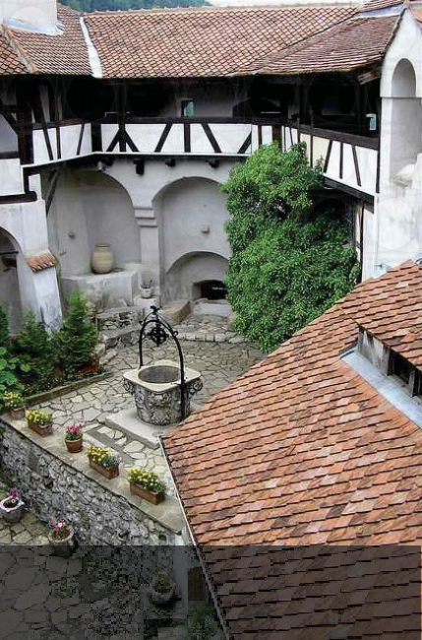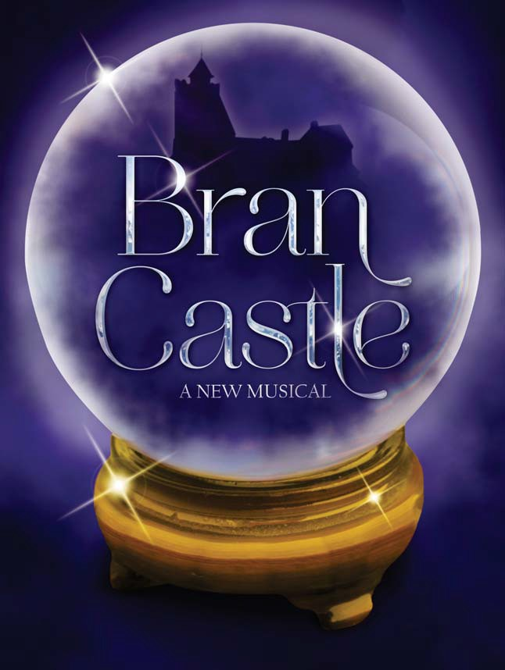**************************************************

Wishing Well in the interior courtyard of Bran Castle.

Poster advertising auction in Wallachia. "For sale, a prime lot of Gypsy slaves...in fine condition.'

The Pershing Square Signature Center New York, NY

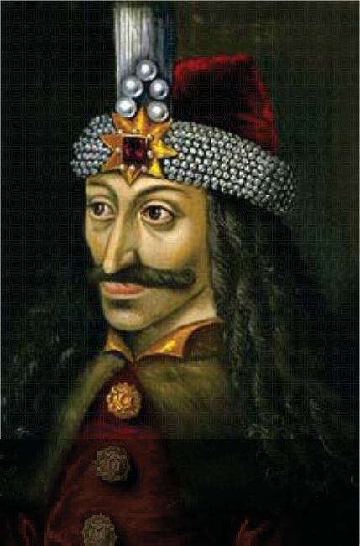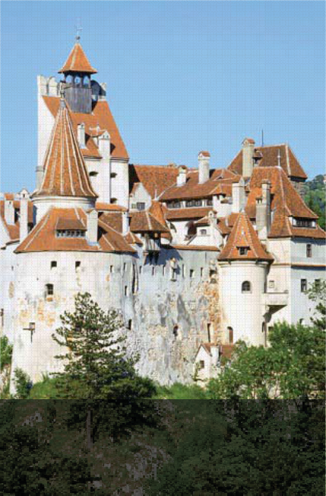

The Ambras Castle portrait of Vlad III, c. 1560, reputedly a copy of an original made during his lifetime.

Bran Castle is located in Romania. It sits on the border between Transylvania and Wallachia.

BRAN CASTLE

A NEW MUSICAL

Music, Lyrics and Book by
Donald Nolan
with

CREATIVE TEAM WHO'S WHO

CATE CAMMARATA {Dramaturg)
Cate Cammarata is a producer, director, freelance dramaturg and writer in NYC
and is the Associate Artistic Director for Rhymes Over Beats. Cate has produced THE ASSIGNMENT off-Broadway, MY FATHER'S DAUGHTER with Ursula Rucker at
LaMaMa for Rhymes Over Beats. Regionally she produced MY LIFE IS A MUSICAL at Bay Street Theater and has directed many readings of new work in NYC. She is the Literary Manager for Theater Resources Unlimited (TRU) and holds a BFA in Acting/Directing from Syracuse University and an MFA in Dramaturgy at SUNY Stony Brook, where she teaches Theatre Arts. Her latest book, Contemporary Monologues for a New Theater, will be published by Applause Books in September.

Tsebiyah Mishael Derry*
Tamra Hayden* Kevin McGuire*
Logan Pitts Brian Sills*
Jenna Leigh Green*
Luke Hoback* Michelle Pauker* Erik Ransom*
Debbie Christine Tjong* Jeff Williams*

Production Stage Manager

JANE POLE*

Casting by
P.J. Griffith*
Tara Martinez Tony Perry* Isabel Santiago* Chloe Tucker*

STEPHANIE KLAPPER, CSA {Casting)
Stephanie Klapper's work is frequently seen on Broadway, Off-Broadway, regionally, internationally, on television, film and the internet. Resident Casting Director for Primary Stages and continues her long collaborations with numerous companies such as Mint Theater Company, New York Classical Theatre, Hudson Valley Shakespeare Company, Masterworks, and Resonance Ensemble as well as others in NYC and in the regions. Currently has a number of very exciting projects running and upcoming in NYC, regionally and on film. Recent projects include: A Letter to Harvey Milk; First Love; Red Roses, Green Gold; Pride and Pre}udice (Kate Hamill ); The Suitcase Under The Bed; Sweeny Todd (KCR); The Mecca Tales; Westside Story (Philadelphia Orchestra); Epiphany V(short film). Member: Casting Society of

STEPHANIE KLAPPER CASTING, CSA

Musical Direction by
ANDY PETERSON

Directed by
RACHEL KLEIN

*Denotes Member of Actors Equity Association
America.

STAFF

GENERAL MANAGEMENT...............................................DTE Management Services
Ryan Conway, Robert E. Schneider PRODUCTION STAGE MANAGER...........................................................Jane Pole*
ASSISTANT DIRECTOR..............................................................Lindsay Wormser

ASSISTANT MUSIC DIRECTOR.........................................................Luke Williams

ASSISTANT STAGE MANAGER...........................................................Kelly Hardy*

CASTING.............................................................Stephanie Klapper Casting, CSA

CASTING ASSISTANTS................................................Lacey Davies, Leah Shapiro

PRODUCTION ADMINISTRATOR...................................................Leandra Montero

GENERAL MANAGEMENT INTERNS........................Madison Kaminski, Steven Breiter

*Denotes Member of Actors Equity Association

CREATIVE TEAM WHO'S WHO

DONALD NOLAN {Book, Music & Lyrics)
Bran Castle was written and developed by Donald Nolan through a workshop program at Midwest New Musicals in Chicago. The work was first presented for reading in Los Angeles in August of 2014 at the Academy for New Musical Theatre and more recently was presented for a reading in Chicago as part of Porchlight Music Theater's Off the Porch new musical series. From its first reading in Los Angeles to recent workshops in New York, Bran Castle has come to life as its characters, songs and story have been nurtured by artists whose input has been invaluable. While professionally this writer is first a trial lawyer, the process by which a musical comes to stage remarkably parallels the time commitment, uncertainty, expense, teamwork, consultation and dedication needed to bring a significant case to trial before a jury of twelve. The size of the audience may be greater in theater, but the verdicts of each tell the tale.

RACHEL KLEIN {Director)
Rachel Klein is a NYC based director, of whose work The New York Times has praised: "What makes this show pop is the bracing vision of its director, Rachel Klein." Off-Broadway Direction: Red Roses, Green Gold (Minetta Lane Theatre/featuring the music of the Grateful Dead); Around the World in 80
Days (The Davenport Theatre); The Anthem (The Lynn Redgrave Theatre); Gay Bride of Frankenstein (iStar Theatre Lab). Selected NYC Theatre: Tink! (New York Musical Festival); More Than All the World (adapted from Marlowe's Edward
II); Symphony of Shadows (Jerome Robbins Foundation commission); A Midsummer Night's Dream; Circus of Circus (The House of Yes). Selected Regional and Workshops: Snow (Playwrights Horizons); 54 The Musical; Dracula (Jenny Wiley Theatre). Ms. Klein recently directed the roast of Michael Musto, featuring Rosie O'Donnell, Bruce Vilanch, Bianca Del Rio and Jinkx Monsoon. Rachel is a proud member of the SDC. More Info: www.rachelkleindirector.com

ANDY PETERSON (Musical Director)
Andy is a NY based composer, musical director, arranger and orchestrator originally hailing from the Land Down Under. He holds a Bachelor of Music (Composition) from the Sydney Conservatorium of Music. Composer credits: Razorhurst (Luna Stage), Stalker: The
Musical (New York, Chicago, [upcoming] Sydney), Outlaw (in workshops). Selected Musical Director/Arranger/Orchestrator credits: OFF-BROADWAY: Red Roses, Green Gold (Minetta Lane Theatre), Atomic (Theatre Row). NEW YORK/REGIONAL: More Than All The
World (Theatre for the New City) , Night Tide (NYMF), Shaken, Not Stirred (The Django), Thrill Me (Luna Stage), Grindr: The Opera (CMTF), Baby Fat (La Mama). INTERNATIONAL: Sinbad: The Musical (arranger/orchestrator for the Malaysian Tour), Kiss Me, Kate (conductor for the Chinese Tour), Bare (Sydney), Pippin (Sydney). FILM: Happy Yummy Chicken [starring Taryn Manning from Orange Is The New Black] http://andypetersonmusic.com.au

CAST OF CHARACTERS

MIRELA ISABEL SANTIAGO* THE COUNT P.J. GRIFFITH* CARMILLA JENNA LEIGH GREEN* VADOMA TAMRA HAYDEN* BEAUBLAIR BRIAN SILLS* FRANCO KEVIN MCGUIRE* MAESTRO / ENSEMBLE TONY PERRY* CONSTABLE / ENSEMBLE JEFF WILLIAMS* DEPUTY / ENSEMBLE ERIK RANSOM* ENSEMBLE LUKE HOBACK* ENSEMBLE LOGAN PITTS MISS JIA / ENSEMBLE DEBBIE CHRISTINE TJONG* OBAYO / ENSEMBLE TSEBIYAH MISHAEL DERRY* YESSENIA / ENSEMBLE TARA MARTINEZ ENSEMBLE MICHELLE PAUKER* ENSEMBLE CHLOE TUCKER*

*Denotes Member of Actors Equity Association

A NOTE FROM THE AUTHOR

Thank you for coming to the reading of Bran Castle. This is an important part of bringing a new musical to the public. Your opinions are important to us as we continue to develop this work for production. You can visit our website at www.brancastlethemusical.com where some recordings of the songs can be found. To that extent, we ask that you respond to the questionnaire that you will
receive by email after the reading. The questionnaire can also be answered online
at https://davenporttheatrical.wufoo.com/forms/bran-castle-reading-survey/.

SCENES I MUSICAL NUMBERS

ACT I

SCENE 1: At the Roma Slave Camp of Bran Castle, 1847
FREEDOM Vadoma, Yessenia, Maestro, Chorus

SCENE 2: At the Crossroads Cemetery
COME THE DARKNESS The Count
I'M NOT A DREAM Mirela, The Count

SCENE 3: At Bran Castle In Carmilla's Tower
SCENES I MUSICAL NUMBERS
ACT II
SCENE 1: Vadoma's Wagon
CRYSTAL BALL Mirela, Vadoma, Maestro, Yessenia

SCENE 2: At Bran Castle in Carmilla's Tower
I'M BEAUBLAIR REPRISE Obayo, Miss Jia, Beaublair, Carmilla

SCENE 3: The Castle Courtyard
CHERNOBOG Franco

PAS DE DEUX AMOUR

SCENE 4: At the Roma Slave Camp
Obayo, Miss Jia
WISHING WELL Mirela YOU'LL BE MY WINE Carmilla

VADOMA'S WAGON Maestro, Yessenia, Mirela
I'M BEAUBLAIR Beaublair, Vadoma FREEDOM REPRISE Vadoma

SCENE 5: At the Crossroads
MY MOTHER'S TAMBOURINE Mirela

SCENE 6: At the Hot Springs
CHOICES The Count, Franco
IS THIS FINALLY THE NIGHT Mirela, The Count

SCENE 4: At the Roma Slave Camp
TURN DOWN THE SHEETS
SCENE 5: Vadoma's Wagon
PRELUDE TO DARK SIDE OF HEAVEN DARK SIDE OF HEAVEN
SCENE 6: The Castle Main Floor
Beaublair
Mirela

THE ROMA QUEEN The Count, Mirela, Beaublair, Vadoma

SCENE 7: The Dining Room at Bran Castle
A GOLDEN OPPORTUNITY

SCENE 7: In the Throne Room
Franco, Beaublair, Deputy, Constable,
Carmilla, Miss Jia

A FINE TABLE Franco BALLERINA, BALLERINA Carmilla
GRAND JETE Miss Jia, Carmilla

SCENE 8: At Bran Castle in the Guest Suite
ROMANCE Franco, Mirela
THIS NIGHT Mirela, The Count, Vadoma, Chorus

PRAYER

SCENE 9: At Bran Castle The Main Hallway
Carmilla

SCENE 10: In the Throne Room
SECRET TREASURES The Count, Mirela

BLACK ROSES
The Count, Carmilla, Beaublair, Franco, Obayo, Vadoma, Mirela, Maestro

****10 MINUTE INTERMISSION****

SPECIAL THANKS PEARL STUDIOS
THE PERSHING SQUARE SIGNATURE CENTER

